**HazPak E-Learning Portal**

**(For Admins)**

Written by: Sim Yu Bo

**Admin User Guide**

# Logging In

**Step 1:**

Access the E-learning Portal Open your preferred web browser (e.g., Google Chrome, Mozilla Firefox). In the address bar, enter the URL provided by your organisation to access the E-learning portal. Press "Enter."

**Step 2:**

Enter Username and Password On the login page, you will see fields labeled "Username" and "Password." In the "Username" field, type in your unique username/identifcation. This will be provided by your organisation. In the "Password" field, enter your password. Passwords are case-sensitive, so make sure to enter it exactly as you created it.

**Step 3:**

Click "Sign In" Once you've entered your username and password.

# Creating questions

**Step 1:**

Look for the "Question Bank" option in the navigation menu or on the dashboard. Click on it to access the Question Bank page. Upon accessing the Question Bank page, you'll see a datatable displaying existing questions. The datatable columns include "Question Text," "Question Type," "Edit," and "Delete." A screenshot of a computer

**Step 2 (MCQ):**

To add a new question, locate the "Add Question" button. Click on it. A modal will appear, prompting you to enter the new question details.

Fill in the "Question Text" field with the actual question.

There is an optional image field that you can add.

Select the appropriate "Question Type" from a dropdown menu, there is an “Add Field“ button which allows you to create more options, then there will be a radio button that you need to select to indicate the correct answer.

Once the information is entered, click the "Submit" button within the modal. Then you should see the new question added.

**Step 2 (Fill in the Blanks):**

To add a new question, locate the "Add Question" button. Click on it. A modal will appear, prompting you to enter the new question details. Fill in the "Question Text" field with the actual question. There is an optional image field that you can add. Select the from the dropdown list, “Fill in the blanks” there is an “Add Answer“ button which allows you to create more answers. Once the information is entered, click the "Submit" button within the modal. Then you should see the new question added.

# Creating Assessments

**Step 1:**

Look for the "Assessments" option in the navigation menu or on the dashboard. Click on it to access the Assessments page. Upon accessing the Assessments page, you'll see a datatable displaying existing assessments. The datatable columns include "Assessment name," "Release datetime,” “Created By” “Edit," and "Delete."

**Step 2:**

Click the "Create Assessment" button to trigger a pop-up form. Within the form, provide the essential details for the assessment. Upon clicking the "Select Questions" option, a modal window will appear, enabling users to select questions from the question bank to include in the assessment.A screenshot of a computer

# Creating exercises

**Step 1:**

Look for the "Exercises" option in the navigation menu or on the dashboard. Click on it to access the Assessments page. Upon accessing the Exercises page, you'll see a datatable displaying existing exercises. The datatable columns include " Exercise name," "Release datetime,” “Created By” “Edit," and "Delete."

**Step 2:**

Click the "Create Exercise" button to trigger a pop-up form. Within the form, provide the essential details for the exercise. Upon clicking the "Select Questions" option, a modal window will appear, enabling users to select questions from the question bank to include in the exercise.

# Creating courses

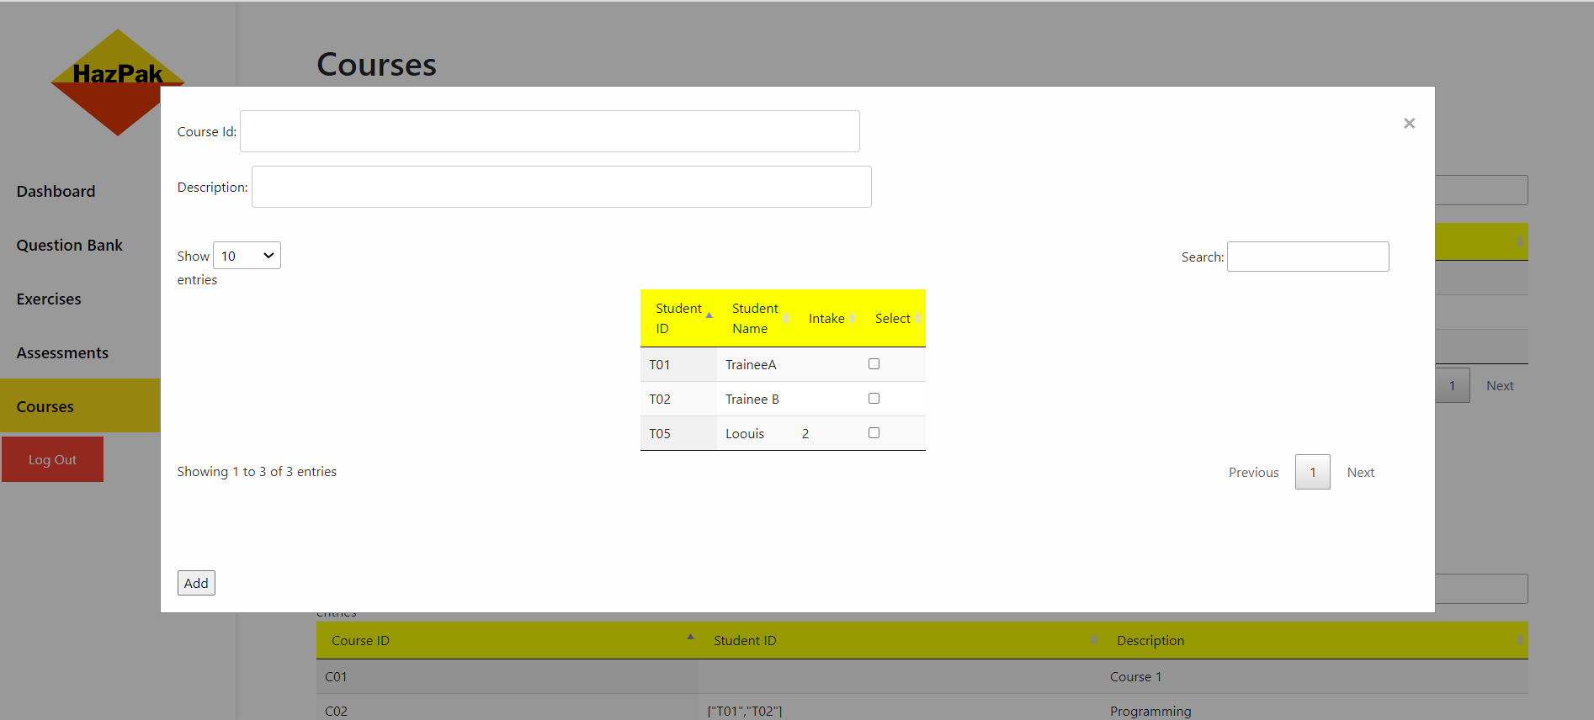

**Step 1:**

Look for the "Courses" option in the navigation menu or on the dashboard. Click on it to access the Courses page. Upon accessing the Courses page, you'll see a datatable displaying existing trainees and courses. The first datatable columns include " Student_ID," "Student Name,” “Intake” “Edit," and "Delete." The second datatable columns include "Course_ID," "Student ID” and “Description”

Step 2:

Click the "Add course" button to trigger a pop-up form. Within the form, provide the essential details for the course.

# adding Trainees

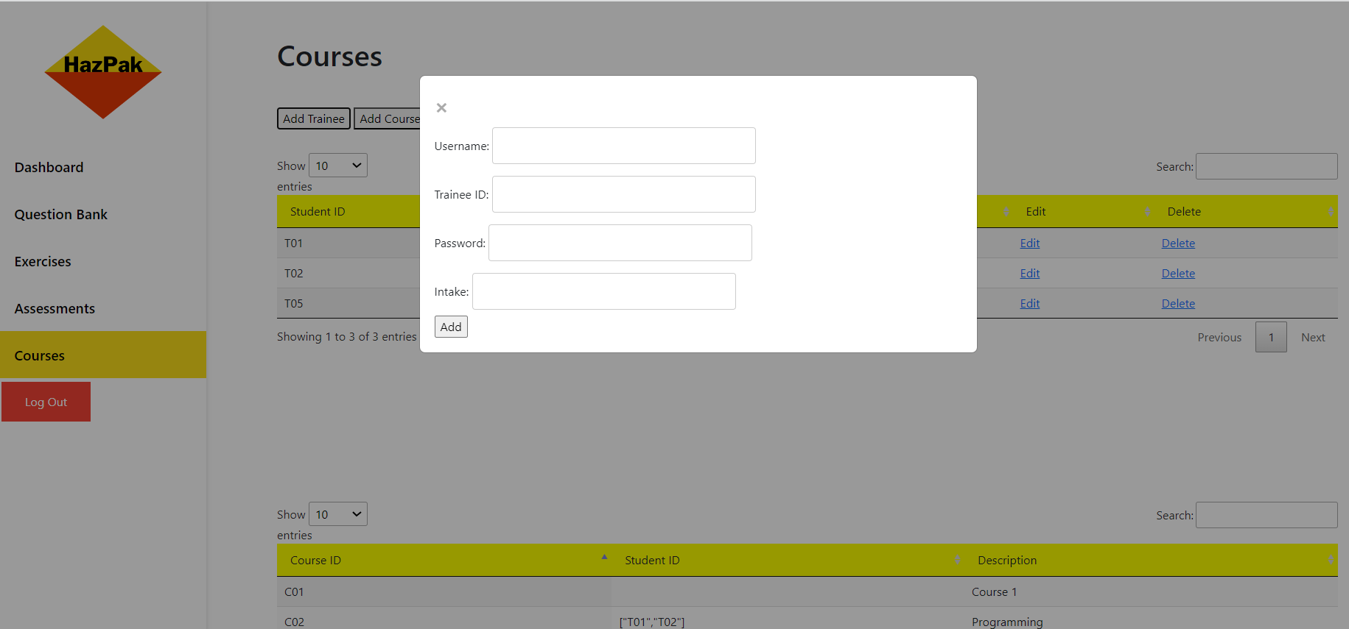

**Step 1:**

Look for the "Courses" option in the navigation menu or on the dashboard. Click on it to access the Courses page. Upon accessing the Courses page, you'll see a datatable displaying existing trainees and courses. The first datatable columns include " Student_ID," "Student Name,” “Intake” “Edit," and "Delete." The second datatable columns include "Course_ID," "Student ID” and “Description”

Step 2:

Click the "Add trainee" button to trigger a pop-up form. Within the form, provide the essential details for the tr.